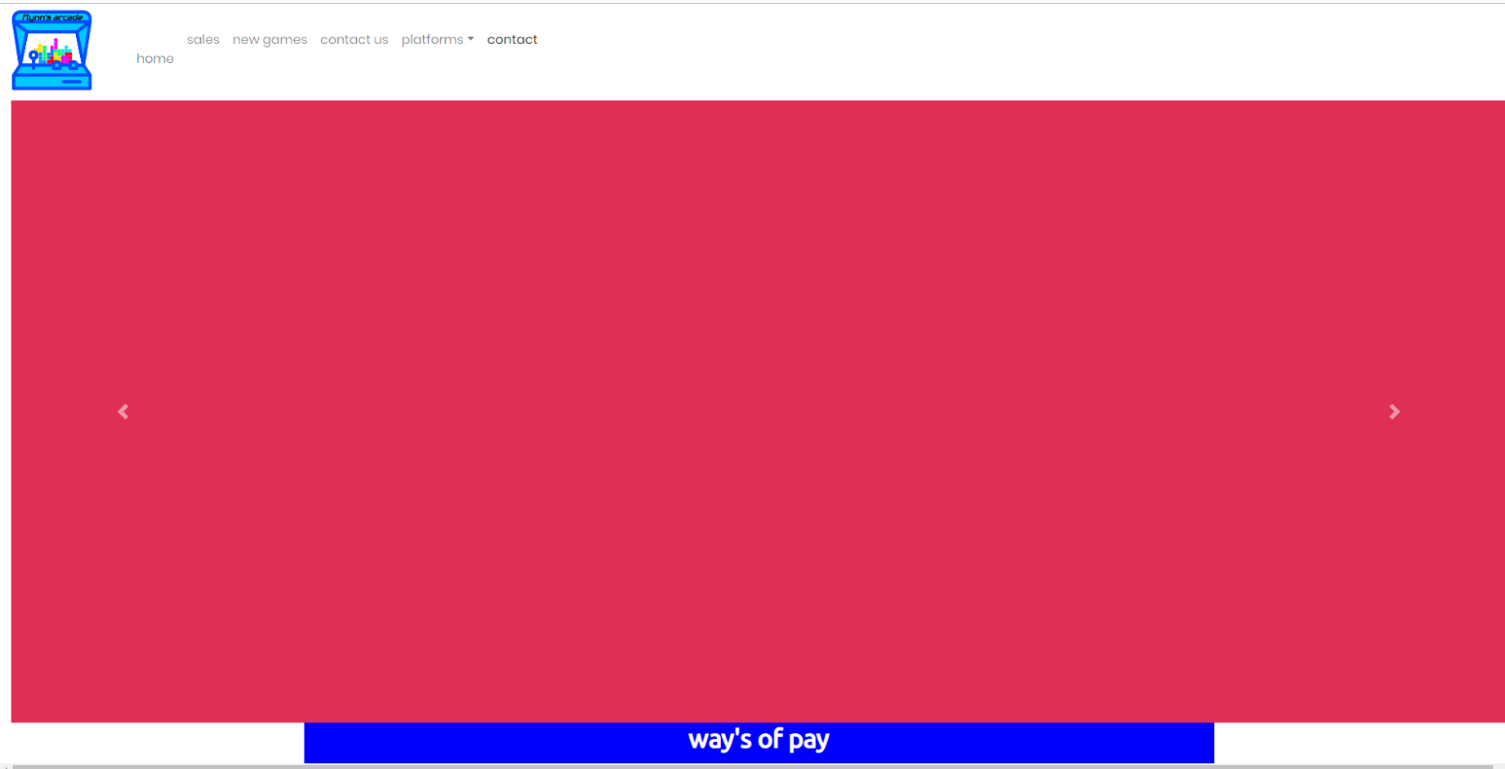

Flynn’s website

Leroy | Flynn’s website | 29/08/19

Contents

Heading 1 3

Areas of investlgation 3

Wix 3

Squarespace 3

Weebly 4

Sitebuilder 4

Webflow 4

Heading 2 5

desing sketches 5

Heading 3 6

final concept design 6

Heading 4 7

design changes 7

Bibliography

https://www.[sitebuilderreport](https://www.sitebuilderreport.com/weebly-review).com/weebly-review

<https://www.weebly.com/au/themes/merch-theme/818920441826955126#/>

<https://www.websitetooltester.com/en/reviews/squarespace-review/>

<https://www.wix.com/>

<https://www.sitebuilder.com/>

<https://webflow.com/>

# Heading 1

## Areas of investlgation

Comparison of others platforms that could have been used to make and design our website. Used notepad++ do write code for our website. Notepad++ is text editor and source code editor that can be used to re-write computer programs or be used to create a website in a web browser, we could have used of used other platform to create our website such as a service called wix, weebly, sitebuilder, webflow and squarespace, these are all examples of different platforms that could have been used to create our website.

### Wix

Wix is a platform that doesn’t need you to write code it lets you chose a template and see if it’s free and click edit to start on your new website, you’re greeted with a preexisting menu, working button and hyperlinks that leads to services, blogs and contact pages wix is an easy to use drag and drop website creator platform that sucks all the work out of making a website.

### Squarespace

Another example of a different platform is squarespace a drag and drop site like all of the examples I’ve said before and also a pay for site as well all the other examples written about before. Squarespace is a pay for site that allows you access to hundreds of templates and styles of our choice they let you chose and design what you want and create your website about anything you want, but squarsapce usually prides themselves on being the number one site used to make blogs online business and self-portfolios as mentioned before the site is a pay for site that ranges from $16 to $52 from self-websites to advance online shops and there payment methods are payed from year to year bassist. There designs are easy to comprehend and you can adjust every little detail and their websites are available on any sized screen fro0m mobile to wide screen monitors and if you’re not happy with your template you could change it and nothing would be lost you would only have to move around images to suit your new template you can even create a website from the mobile phone app. There are some cons to the website like how you can’t write a multi lingual website and that some of the design features are unusable

### Weebly

Weebly is no squarespace and is not anything like wix, wix is flexible and squrasapce is sophisticated, it’s a watered down version of a website it’s easy to use and simple for anyone to understand its clean and a drag and drop to add something to your website making it easy for first time comers trying to build the online empire. Although they have small amount of templates to your disposal there pricing is very affordable. Form the basic to being free to $42 advanced online business/shop which goes into mass amount of detail and explain to you what you’re paying for unlike the examples where written about before there platform is easy to use and for the genial public they aim to be assessable and take away all complication’s.

### Sitebuilder

Sitebuilder is pay for site that dose go into depth on what you’ll have to do and what you’ll need to pay. When you first go to the website it tells you what you need to do to get your website up and running one step being you need to pay. You need to pay to even have a look at the templates and custom options. According to reviews on sitebuilder they have over 100 different templates and is reviewed with 4’s and 5’s simply because it’s easy to use and a drag and drop.

### Webflow

Webflow is an easy to use drag and drop website builder that sets you off with a blank template and lets you create whatever you want but if you want an already designed template that will cost you between $150 and free most of them being simple and easy to work around much like the site builder itself being easy to understand and work off. When you first lode into the site it walks you through what you need to do to create a working website and goes into great detail on why you should use webflow and how it will benefit you . Webflow is an easy to use site that tells you what you’re getting in to before you start

### notepad++

Note pad++ is a free appellation that you download on a web browser that always you to edit and write code that always you create style all for free but its more completed then a simple drag and drop site you need to learn code but with help of other site such as bootstrap most can be done for you. You’ll still need to understand code so you know where to go and customize what you need to, to suit what you want for your website.

# Heading 2

## desing sketches

My design

# Heading 3

## final concept design

# Heading 4

## design changes